# AXIOS

Package to make http requests. Using jsonplaceholder here for dummy http requests/data

npm install axios –save

Make requests in ComponentDidMount. Asynchronously perform requests, so this implements promises which mean get usea promise then which gets executed when then data is returned back from the request

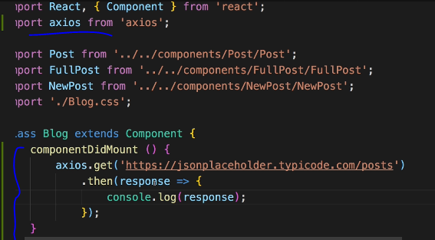

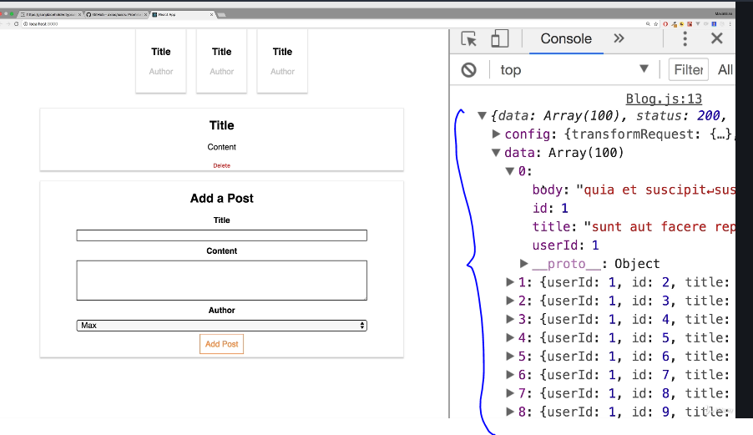

One example of data transformation after data get

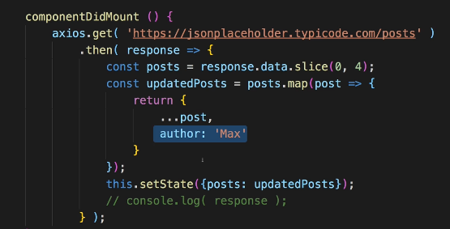

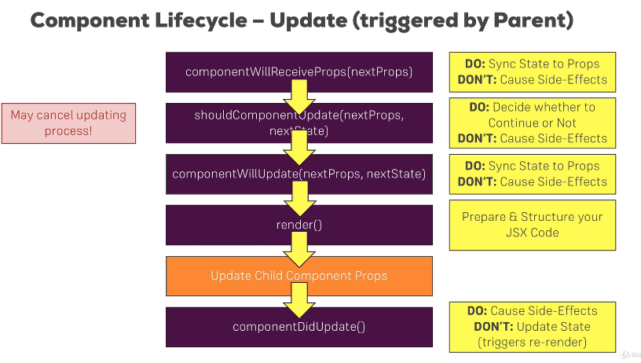

Infinite loop in componentdidupdate below: setstate will call the same method again and again.

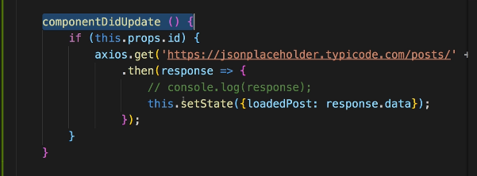

Inorder to avoid infinite loop add a condition to make a get call only upon a change in the request id as below, and also check for not null loadedPost data

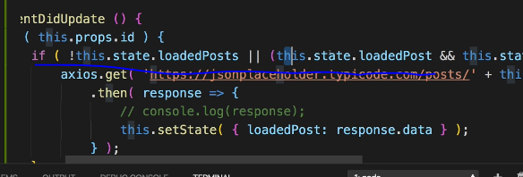

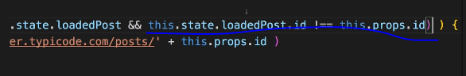

Axios POST EXAMPLE: Takes a js object and the data is sent in json format

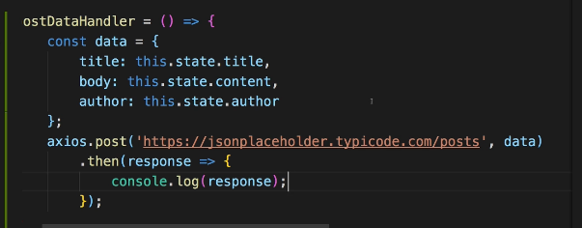

AXIOS delete example

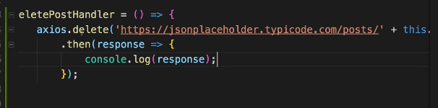

Catch error in axios calls using catch

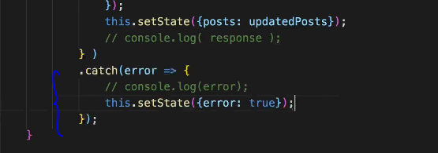

And load page content based on the error

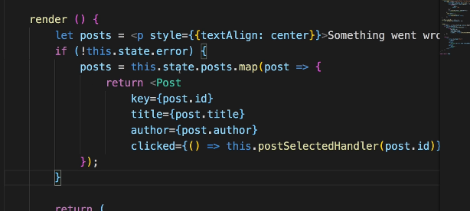

# Interceptors

Add Interceptors to Execute code globally.

For example, to globally execute any method globally on axios get/post/delete calls.

Interceptors are functions that will be executed globally upon every request leaving the app or upon every response returning to the app.

Examples: to set authorization headers, to log responses or log errors globally.

Below screen shows the interceptors added to index.js (parent page) where the application root element is created.

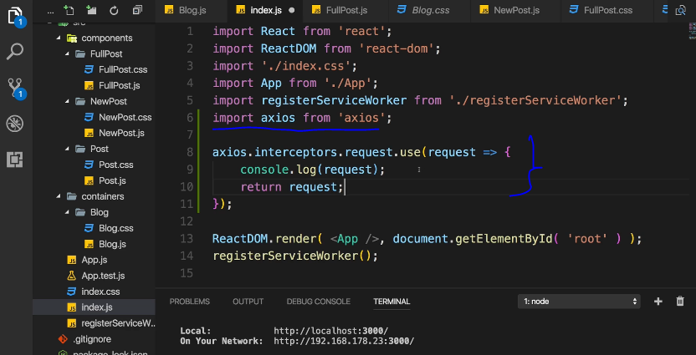

We can also pass another function, error to log any errors globally and return the promise.reject to continue the call and to be able to handle the error locally in the catch block of the request as well.

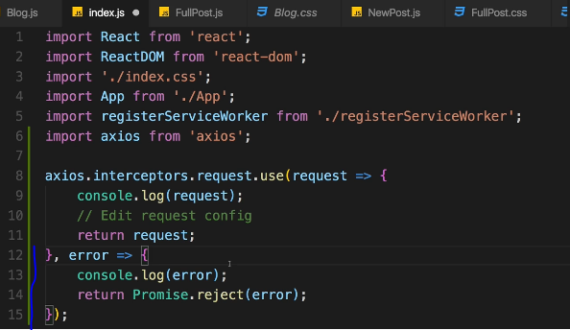

To handle responses for globally manipulating the responses or logging them:

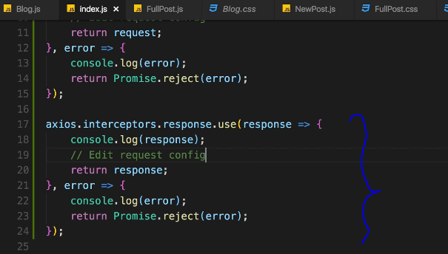

Removing Interceptors

getting rid of one is also easy. Simply store the reference to the interceptor in a variable and call eject  with that reference as an argument, to remove it (more info: <https://github.com/axios/axios#interceptors>):

var myInterceptor = axios.interceptors.request.use(function () {/*...*/});

axios.interceptors.request.eject(myInterceptor);

Setting a default global configuration:

To set a default base url for every request as below

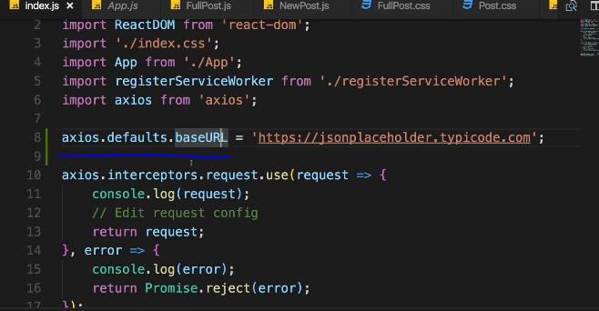

Now, the base url is default appended to every request:

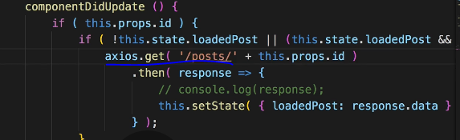

Other examples: setting default configurations that can be used application wide.

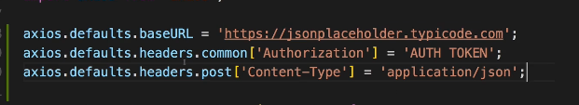

Creating and using AXIOS instances

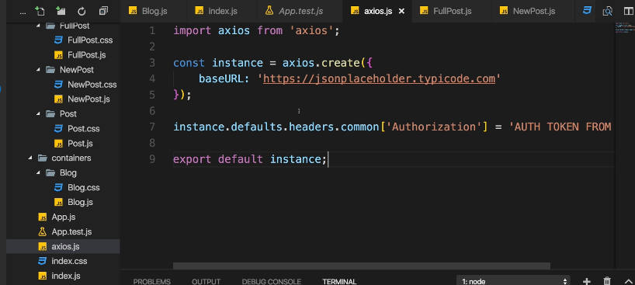

TO USE THIS instance specific file, just use as below, instead of global in any file. These settings will overwrite global settings

